
KARATINA UNIVERSITY
UNIVERSITY EXAMINATIONS
2024/2025 ACADEMIC YEAR

THIRD YEAR FIRST SEMESTER EXAMINATION
FOR THE DEGREE OF

BACHELOR OF SCIENCE IN COMPUTER SCIENCE, & INFORMATION TECHNOLOGY.

COURSE CODE: BIT 317

COURSE TITLE: NETWORK DESIGN & CONFIGURATION
DATE:9 ^{th} JANUARY 2025 TIME: 9.00am- 11.00am
INSTRUCTION TO CANDIDATES
- SEE INSIDE

Instructions: Answer ALL Questions in QUESTION ONE and ANY other TWO QUESTIONS.

QUESTION ONE: (30 MARKS) (COMPULSORY)
- Local Area Networks (LANs) rely on various types of transmission media to facilitate data communication. Describe three of the most common types of transmission media used in LAN environments, highlighting their characteristics (6 marks)

- Router A (RTA) needs to forward the packets to the destination address 30.1.2.0/24. Write the command to configure a static route for the enteprise network shown below (3 marks)
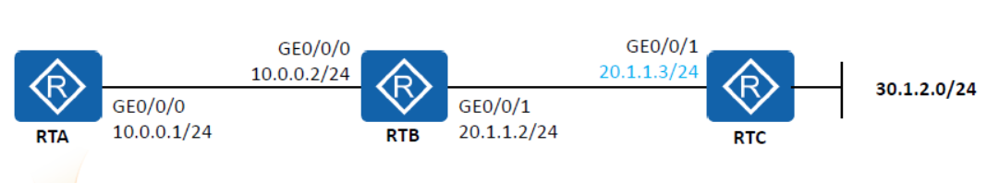
- On VRP platform, the command lines are classified into several levels of increasing priority. Describe any three of these levels. For each level, include examples of use cases that demonstrate the type of commands typically found in that level. (6 Marks)
- A router forwards packets based on its IP routing table. To implement route-based packet forwarding, the router needs to obtain routes. Describe three common methods of obtaining routes. (6 Marks)

- Internet Protocol version 4 (IPv4) is the underlying technology that makes it possible for us to connect our devices to the web. Elaborate the following
- The ranges of three IPv4 classes and their default subnet masks
(3 Marks)
- Total number of hosts in each class. Show your working
(3 Marks)

- OSPF sends packets to neighbors to establish and maintain adjacencies. Discuss three types of OSPF protocol packets that implement different functions in interaction between OSPF routers. (3 Marks)
QUESTION TWO: (20 MARKS)
- You have been hired as a network administrator for a growing startup company. The company has recently expanded its office space and needs to set up a new Local Area Network to accommodate the increasing number of employees and devices.
Required:
- What is meant by the term Local Area Network? (1 Marks)
- Analyze two topologies that would be suitable for the LAN and, for each one, draw a labelled diagram to show its structure. (4 Marks)
- Discuss three hardware devices that are necessary to set up the LAN. State the functions of each device (6 Marks)
- Analyze three protocols and their functions that are necessary to be configured within the local area network (6 Marks)
- Evaluate any three security considerations that should be considered when setting up a separate wi-fi subnet for guests. (3 Marks)

QUESTION THREE: (20 MARKS)
Karatina University has hired you as a network admin to manage their network. The management has provided you with an IP address range of 10.0.0.0/24 to work with. They require multiple departments to have their own subnets for better organization and security. Using VLSM design a subnetting scheme for the company that meets the departmental requirements as shown in the table below.

Department | Number of devices
ICT Lab 6 | 100 desktops, 2 laptops and 2 printers
Exams Office | 8 Computers and 1 printer
All Faculty Offices | - computers and 1 shared printer
Provide the following details for each subnet: (12 Marks)
- Network Address
- Usable IP Range
- Broadcast Address
- Subnet Mask
- Describe three benefits of subnetting the above local area network. (6 Marks)
- Explain the significance of broadcast addresses in the network. (2 Marks)

QUESTION FOUR: (20 MARKS)
- TCP/IP is a conceptual model that characterizes and standardizes the communication functions of a comuting system. Explain the funtions of each layer in the TCP/IP network achitecture model (10 marks)
- Imagine you are using the Cisco Packet Tracer simulation tool to configure and manage a simulated network environment. Write the commands required to complete the following tasks in the Cisco Packet Tracer simulator:
- Configure a static route on Router A (RTA) to forward packets to the destination address 30.1.2.0/24. (4 marks)
- Set up an IP address on an interface of RTA. (4 marks)
- Verify the routing table to ensure the static route is correctly configured.
(2 marks)
QUESTION FIVE: (20 MARKS)
- You are the network administrator for a medium-sized company. You need to implement access control to enhance network security. The company has the following requirements:
- Allow HTTP (port 80) and HTTPS (port 443) traffic from any source to the web server with the IP address 192.168.1.10.
- Deny all other traffic from the internal network (192.168.1.0/24) to the internet.
- Allow all traffic within the internal network.
Tasks:
- Write the commands required to create a standard ACL that meets the above requirements. (5 marks)
- Apply the ACL to the appropriate interface (assume the internal interface is GigabitEthernet0/1). (5 marks)
- Explain the OSI (Open Systems Interconnection) model. Provide a brief description of each of the seven layers, including their functions and protocols commonly associated with each layer. Additionally, illustrate how the OSI model facilitates network communication. (10 Marks)
- Introduction to OSI Model (1 mark)
- Description of each layer (1 mark each, total 7 marks)
Layer 1: Physical
Layer 2: Data Link
Layer 3: Network
Layer 4: Transport
Layer 5: Session
Layer 6: Presentation
Layer 7: Application
- Illustration of how the OSI model facilitates network communication
(2 marks)

